|  |
| --- |
| L A County Office of Education  Disaster Recovery Plan  2025-05-12  v. 1.5 |

PROPRIETARY AND CONFIDENTIAL

The information contained in this document is legally privileged and confidential to CGI and to the receiving party. This document cannot be reproduced in any form or by any mechanical or electronic means, including electronic archival systems, without the written approval of CGI. The receiving party is exempt from this restriction for evaluation purposes only.

If you have received this document by mistake, note that the reading, the reproduction or the distribution of this document is strictly forbidden. You are hereby requested to inform us by telephone and to return this document by certified mail.

###### Table of Contents

1. Revision History iv

Documentation Framework 6

Copyright 6

Trade Secrets of LACOE 6

2. Document Overview 7

Target Audience 7

3. Terms and Definitions 8

Minimum Resource Configuration 8

Disaster Recovery Lead 8

Disaster Management Team 8

Recovery Teams 8

Crisis Management Center 8

Recovery Recommendations 8

Recovery Procedures 8

3.1 Abbreviations 10

4. Executive Summary 11

5. DR Solution(s) Overview 12

VMware’s Site Recovery Manager (SRM) Role 12

SRM Protection Groups 12

SRM Recovery Plans 12

Storage Array Integration 12

IP Addressing at the Recovery Site 13

DNS at the Recovery Site 13

Active Directory at the Recovery Site 13

Oracle Data Guard Standby Database 14

DR Solution Monitoring 15

6. Technical Recovery Guide Framework 16

Goal 16

Scope 16

Change Management Process 16

Team Responsibilities 16

Human Resources 16

Environment Overview 16

Physical Resources 16

LACOE Network 17

Best Production Site 17

Production VM’s on ESXi Hosts (DW1-ESX111 – 117) 18

BEST Oracle 12c Server 19

Technical Constraints 20

Production Configuration 20

BEST Disaster Recovery Environment 21

Recovered Assets 22

Recovery Configuration 24

Recovery Strategy Defined 25

7. Roles and Contacts 26

8. Appendices 27

# Revision History

|  |  |  |  |
| --- | --- | --- | --- |
| **Version** | **Date** | **Author** | **Description** |
| 0.1 | 11/06/17 | Simon Sylvester | Initial draft |
| 0.2 | 11/27/17 | Eric Mayer | Added Executive Summary and section 4 DR overview |
| 0.3 | 12/3/17 | Eric Mayer | Add specific tasks around solutions capabilities and features. |
| 1.0 | 12/6/17 | Eric Mayer | * Added: Oracle Data Guard Maximum Availability will be used for the Primary Prod DB server to the UAT DB Server for Production maintenance activities. Maximum Performance will be used for the Primary Prod DB and DR site Standby DB Server with an RPO of < 5 minutes. * Added: Under physical resources section Network hardware * Added: section to populate with adding LACOE network support of datacenter infrastructure equipment and configurations to allow traffic to route into the BEST environment * Added: Key Performance Indicators (KPI’s) need to be identified to monitor the health (heartbeat) of key DR systems and synchronization processes so DR RPO/RTO targets are maintained throughout the lifecycle of the solution. * Added: DR site location is still (TBD) * Added: Visio of Oracle data guard and AD solutions/options * Added: DNS entries will be updated statically for both the forward and reverse lookup domains at the DR site within the DR DNS scope. Windows DNS will be used for the BEST environment DNS solution while Infoblox will be used for external name resolution * Corrected DB Prod names in diagram under Recovery Configuration section. |
| 1.1 | 1/3/18 | Eric Mayer | Adding Section 4.1 – Abbreviations |
| 1.2 | 2/19/18 | Eric Mayer | Added Section 7 - VLAN Spanned subnet will be used for the DR site instead of a new subnet under IP Addressing and DNS. |
| 1.3 | 02/21/2020 | Ruben Ybarra  Tom Lundeberg | Updated section 8 with roles and contacts  Updated Section 9 with task list |
| 1.4 | 7/01/2024 | Ruben Ybarra  Ravi Gupta |  |
| 1.5 | 5/12/2025 | Jeff Rhey | Updates to reflect new names of hardware and VMs as well as some terms |

# Documentation Framework

## Copyright

©

## Trade Secrets of LACOE

The following material contains valuable confidential and proprietary information and/or trade secrets of LACOE. The ability to disclose, reproduce or distribute this material, in whole or in part, requires the prior written consent of LACOE.

## Document Overview

The purpose of this document is to define the solution and activities required to fail-over and recover BEST databases and production servers (guests) hosted in the VMware production’s environment in the event of a disaster in LACOE primary datacenter. This DR Plan delineates the components, people, organizations and processes required to affect this system's recovery within its stated Recovery Time Objective (RTO) and Recovery Point Objective (RPO).

## Target Audience

This document is intended for:

* Management Team
* Recovery Teams
* The technical team responsible to perform the recovery of the LACOE BEST production environment

# Terms and Definitions

The following terms are used throughout the Recovery Plans and are defined here for purposes of clarification.

## Minimum Resource Configuration

The Minimum Resource Configuration is a listing of minimum recovery resources that are required by a recovery team over time. Resources include space for recovery personnel, PC’s, telephones, unique equipment, etc. This information will be utilized by the MANAGEMENT TEAM to develop strategies for the acquisition of essential resources at time of disaster.

## Disaster Recovery Lead

The Disaster Recovery Lead makes all decisions related to the Disaster Recovery efforts. This person’s primary role will be to guide the disaster recovery process. All other individuals involved in the disaster recovery process will report to this person if a disaster occurs, regardless of their department and existing managers

## Disaster Management Team

The Disaster Management Team will oversee the entire disaster recovery process. They will be the first team that must take action if a disaster occurs. This team will evaluate the disaster and will determine what steps must be taken to get the organization back to business as usual.

## Recovery Teams

The RECOVERY TEAM is activated following detection of an incident by the MANAGEMENT TEAM. The RECOVERY TEAM is responsible for restoring its critical functions within the time periods specified on the Functions Report.

## Crisis Management Center

The Crisis Management Center is an offsite meeting area from which initial assessment, evaluation, coordination and decision making activities take place. The Crisis Management Center houses the MANAGEMENT TEAM during the initial phases of response and recovery.

## Recovery Recommendations

At time of the incident occurrence, the MANAGEMENT TEAM will identify critical personnel to lead the recovery effort and select appropriate recovery strategies/solutions based on the severity of the incident. These collective strategies and assignments are referred to as the Recovery Recommendations.

## Recovery Procedures

Recovery Procedures document the actions necessary to respond to an incident and eventually restore critical processing. These procedures address both immediate short-term tasks and more time-consuming long-term tasks.

# Abbreviations

|  |  |
| --- | --- |
| Abbreviation | Text |
| SRM | Site Recovery Manager |
| OSI | Operating System Instance – can be physical or virtual |
| SRA | Storage Replication Adaptor |
| DR | Disaster Recovery |
| BC | Business Continuity |
| VMFS | Virtual Machine File System |
| KPI | Key Performance Indicator |
| LUN | Logical Unit Number |
| ESXi | Elastic Sky X installable |
| VDOM | Virtual Domain |
| AD DS | Active Directory Domain Services |
| AD CS | Active Directory Certificate Services |
| PKI | Public Key Infrastructure |
| TDO | Trusted Domain Object |
| DNS | Domain Name System |
| DC | Domain Controller |
| OU | Organizational Unit |
| GPO | Group Policy Object |
| FSMO | Flexible Single Master Operations |

# Executive Summary

The System of Record is the heart of every organization as they are mission critical in order to run the business. The Advantage solution being implemented for BEST is classified as a mission critical system and as such great care must be taken to protect the system, and all its data, from loss. There are several IT solutions and strategies that can be used to protect systems and data from loss. Although this solution document focuses on DR (Disaster Recovery), BC (Business Continuity) planning is also involved as “validation and testing” of the DR plan is essential to every recovery strategy.

The figure below shows where DR solutions merge with BC planning.

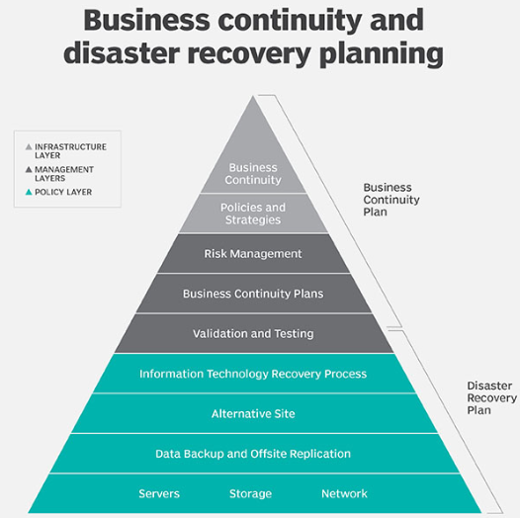

**In this document, we will be focusing on the implementation of the following DR/TEST solutions;**

* VMware vCenter Site Recovery Manager is a management and automation product that helps build, manage, test, and execute disaster recovery plans for a VMware virtual infrastructure. VMware’s Site Recovery Manager (SRM) will be used to orchestrate the DR failover and Test plans for recovering virtual machines, networks, and storage at the remote location.
* Array based replication will be implemented for the Storage Area Network (SAN) data migrations
* Active Directory Replication will be used for the DR site solution
* Dynamic DNS to be implemented at the DR location to assist with VM network IP translations.
* Global Load Balancing to be implemented to re-direct end user traffic from the primary site to the DR location.
* Oracle databases will be protected using Oracle Data Guard as the DR solution.

# DR Solution(s) Overview

## VMware’s Site Recovery Manager (SRM) Role

VMware vCenter Site Recovery Manager is a management and automation product that helps build, manage, test, and execute disaster recovery plans for a VMware virtual infrastructure. SRM will be used as the orchestration and automation tool and integrate with the ALLETRA storage for asynchronous array based replication of the VM’s. The array based replication methodology uses crash-consistent recovery. This means the application has not been quiesced and hence the recovery is that of a machine following a power outage. There is a small probability of data corruption for database type workloads in this type of situation and this is why we’ll be integrating Oracle Data Guard using Maximum Availability Data Guard mode for a no loss recovery of the databases.

## SRM Protection Groups

Applications can be run on multiple servers that have dependences on each other. In order for the application to function properly when it comes online, SRM groups systems that support the same application services within a recovery protection group. A protection group is a group of virtual machines that fail over together to the recovery site. Protection groups contain virtual machines with data that has been replicated by array-based replication. A protection group could contain virtual machines that are all part of an application three-tiered architecture (application server, database server, and web server) and/or virtual machines with virtual machine disk files that are part of the same data store group.

## SRM Recovery Plans

Protection groups are the building blocks of recovery plans. A protection group can be included in multiple recovery plans. Each recovery plan is a sequence of steps executed to recover virtual machines in a specified sequence with specified priority. Each individual application can have its own recovery plan and can be recovered independently of others. Most applications have dependencies on infrastructure components such as Active Directory and DNS. The infrastructure protection group needs to be included in most application recovery plans so that the application is usable after recovery. A recovery plan for the entire site (All) can include all applications. The recovery plan allows setting of priorities for applications to create an order for the recovery process.

## Storage Array Integration

The HPE ALLETRA Storage system, as the storage component in a VMware virtual infrastructure, holds virtual machine information for a protected site/location and recovery site/location. HPE ALLETRA Storage Replication Adapter (SRA) for VMware vCenter SRM is an important integration component that communicates with HPE ALLETRA Storage systems to execute specific storage and HPE ALLETRA Remote Copy functions needed for VMware vCenter Site Recovery Manager operations. When creating virtual volumes and presenting them to the ESXi host(s), the same LUN ID is required to be used for every host in the same access group; and, LUNs must be presented to each HBA of each host. When leveraging an HPE ALLETRA virtual volume set, we need to include all virtual volumes in a single HPE ALLETRA Remote Copy group and in the same protection group. Replication occurs every 30 minutes at the HP ALLETRA Array.

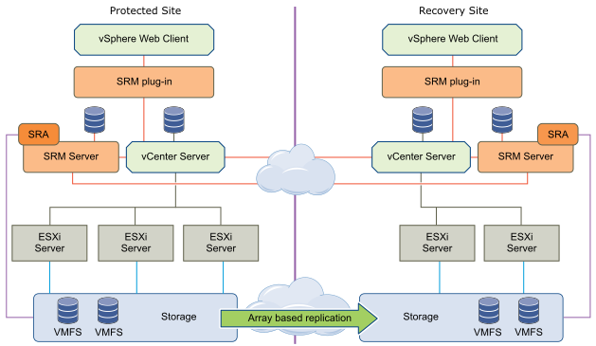

## IP Addressing at the Recovery Site

For the LACOE BEST environment, the recovery site will be using the same IP addresses as the primary site.

## DNS at the Recovery Site

All VM’s will be using Windows DNS services on the BEST Active Directory Controllers at the primary site and the DR site.

## Active Directory at the Recovery Site

Domain Controllers at the primary site will be the holders of the Flexible Single Master Operation Roles (FSMO) these roles are required for the domain controllers to function correctly. Forest Wide Roles: Schema Master and Domain naming master. Domain Wide Roles: PDC RID pool manager and Infrastructure. The primary site AD will be replicating to the DR site for DR/BC purposes. Only during a real DR situation should the FSMO roles be manually seized by the DR site replicated AD. The risk of introducing a former FSMO role holder whose role has been seized into the forest is that the original role holder may continue to operate as before until it inbound-replicates knowledge of the role seizure. Known risks of two domain controllers owning the same FSMO roles include creating security principals that have overlapping RID pools, and other problems. A domain controller whose FSMO roles have been seized should not be permitted to communicate with existing domain controllers in the forest. In this scenario, you should either format the hard disk and reinstall the operating system on such domain controllers or forcibly demote such domain controllers on a private network and then remove their metadata on a surviving domain controller in the forest.

For Test DR scenarios it is recommended to transfer the Schema Master, Domain naming master, PDC, RID pool manager and Infrastructure FSMO roles to the AD103 server at the DR site and transfer back to the primary AD servers when the test has been completed.

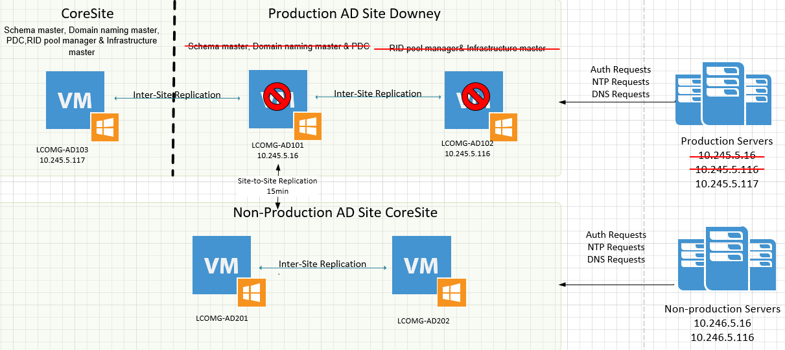

## Oracle Data Guard Standby Database

Oracle Data Guard provides the management, monitoring, and automation software infrastructure to create and maintain one or more standby databases to protect Oracle data from failures, disasters, errors, and data corruption. A stand-by database is a database copy that is in a constant state of recovery. The stand-by database is a near-real-time replica of the primary database located at the DR site. Maximum Availability is the most common Data Guard usage mode as it allows for the synchronous transportation of the redo stream. In this mode, no data is typically lost, because the primary and standby are in sync. Maximum Availability will be used for the Primary Prod DB server to the UAT DB Server for Production maintenance activities. Maximum Performance will be used for the Primary Prod DB and DR site Standby DB Server with an RPO of < 5 minutes.

The failover/failback of the Oracle Databases will be manual. VMware Site Recovery Manager will not be used to orchestrate these activities etc.

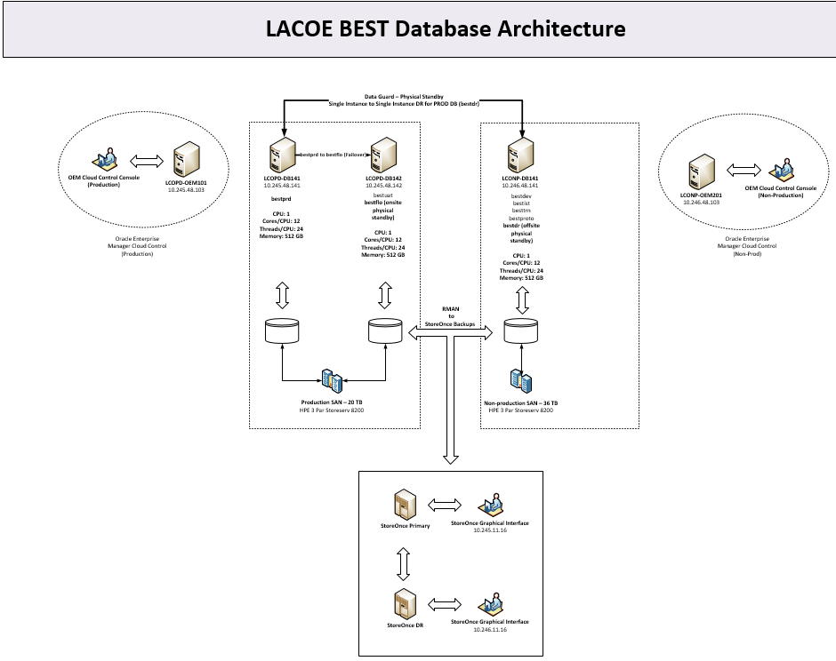

## DR Solution Monitoring

Key Performance Indicators (KPI’s) need to be identified to monitor the health of key DR systems and synchronization processes so DR RPO/RTO targets are maintained throughout the lifecycle of the solution.

# Technical Recovery Guide Framework

## Goal

Provide focused and complete information to carry out the recovery of the BEST Advantage Production environment to the DR site.

## Scope

This document contains recovery procedures and general information to recover the servers in the BEST production environment to its recovery site in CoreSite. It has been drafted for use during a disaster recovery as well as during a disaster recovery exercise; the differences in procedure between the two are to be clearly identified.

During a disaster recovery exercise - or in a real situation, the following will need to be documented.

1. Time required for each activity
2. Problems encountered
3. Problem analysis
4. Corrective measures taken
5. Unresolved problems to be follow-up on

## Change Management Process

The change management process describes all the steps to implement any change, including the update to the recovery documentation and/or configuration. It is mandatory to follow that process to maintain a safe Disaster Recovery plan.

During an actual disaster declaration**,** the change management process will be suspended until the complete recovery of the BEST production environment.

## Team Responsibilities

In a Disaster Recovery situation or in a Disaster Recovery Exercise, the responsibilities are:

* Perform all the pre-requisites activities;
* Perform all the recovery activities;
* Support all the client recovery activities;
* Document all incidents;
* Provide an “all-clear” at the end of the Disaster Recovery Exercise or when the situation returns to normal.

## Human Resources

* Minimum 1 resource per technical tower (Wintel, storage, network, VMWare) onsite at the same time.

## Environment Overview

* BEST **Production** is hosted in LACOE’s primary Data Center
* BEST **Recovery** is hosted in CoreSite

## Physical Resources

* BEST database servers are warm in the recovery location
* vCenter, SRM (and by extension ESXi) servers are hot at the recovery site
* ESXi servers at the recovery site have access to the same VLANs as the production ESXi servers
* AD/DNS services are available at the recovery site
* Network switches/routers/firewalls/load balancers

## LACOE Network

The BEST Advantage environment is hosted within the LACOE datacenter and the network support is a key underpinning contract to manage the solutions SLA’s. (This section will be filled out as the Network Team)

## Best Production Site

* The LACOE BEST Production site is hosted in the LACOE primary data center, and its recovery site is hosted at CoreSite data center.
* The major infrastructure components include:
  + Networking, Servers, and Storage is operational at the CoreSite Data Center (SECONDARY DC) using Active Directory Replication
* The Production ESXi environment at the PRIMARY DC consists of the follow Hardware/Systems

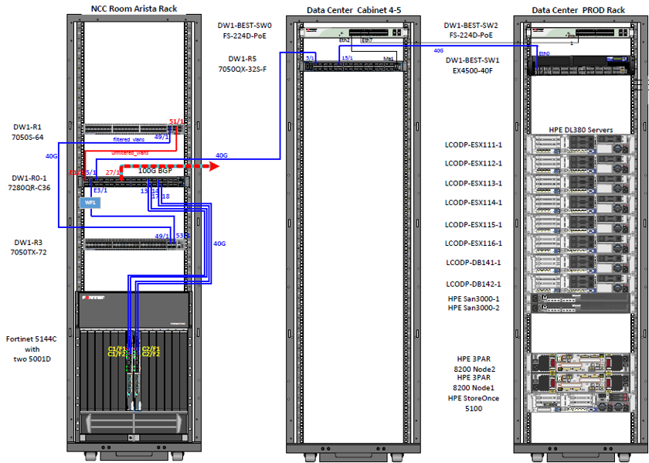

## Production VM’s on ESXi Hosts (DW1-ESX111 – 117)

|  |  |  |  |  |  |  |  |  |  |  |  |  |  |  |  |  |  |  |  |  |  |  |  |  |  |  |  |  |  |  |  |  |  |  |  |  |  |  |  |  |  |  |  |  |  |  |  |  |  |  |  |  |  |  |  |  |  |  |  |  |  |  |
| --- | --- | --- | --- | --- | --- | --- | --- | --- | --- | --- | --- | --- | --- | --- | --- | --- | --- | --- | --- | --- | --- | --- | --- | --- | --- | --- | --- | --- | --- | --- | --- | --- | --- | --- | --- | --- | --- | --- | --- | --- | --- | --- | --- | --- | --- | --- | --- | --- | --- | --- | --- | --- | --- | --- | --- | --- | --- | --- | --- | --- | --- | --- |
| |  |  | | --- | --- | | **Production VMs** | **Description** | | LCOPRD-WEB101L.best.lacoe.edu | Production Apache Web Server | | LCOPRD-WEB102L.best.lacoe.edu | Production Apache Web Server | | LCOPRD-WEB103L.best.lacoe.edu | Production Apache Web Server | | LCOPRD-WEB104L.best.lacoe.edu | Production Apache Web Server | | LCOPRD-FIN101L.best.lacoe.edu | Production Advantage Financial Server | | LCOPRD-FIN102L.best.lacoe.edu | Production Advantage Financial Server | | LCOPRD-BUD101L.best.lacoe.edu | Production Performance Budgeting Server | | LCOPRD-BUD102L.best.lacoe.edu | Production Performance Budgeting Server | | LCOPRD-HCM101L.best.lacoe.edu | Production Advantage HRM, ESS, and MSS Server | | LCOPRD-HCM102L.best.lacoe.edu | Production Advantage HRM, ESS, and MSS Server | | LCOPRD-HCM103L.best.lacoe.edu | Production Advantage HRM, ESS, and MSS Server | | LCOPRD-HCM104L.best.lacoe.edu | Production Advantage HRM, ESS, and MSS Server | | LCOPRD-HCM105L.best.lacoe.edu | Production Advantage HRM, ESS, and MSS Server | | LCOPRD-HCM106L.best.lacoe.edu | Production Advantage HRM, ESS, and MSS Server | | LCOPRD-HCM107L.best.lacoe.edu | Production Advantage HRM, ESS, and MSS Server | | LCOPRD-HCM108L.best.lacoe.edu | Production Advantage HRM, ESS, and MSS Server | | LCOPRD-INFO101W.best.lacoe.edu | Production infoAdvantage and Business Objects Server | | LCOPRD-INFO102L.best.lacoe.edu (unused) | Production infoAdvantage and Business Objects Server | | LCOPRD-ETL101W.best.lacoe.edu | Production ETL Process and PDI Interfacing Server | | LCOPRD-ETL102W.best.lacoe.edu (unused) | Production ETL Process and PDI Interfacing Server | | LCOPRD-BIRT101W.best.lacoe.edu | Production BIRT Forms Server (FIN) | | LCOPRD-BIRT102W.best.lacoe.edu | Production BIRT Forms Server (HCM) | | LCOPRD-RCH102L.best.lacoe.edu | Production RICOH Print Server | | LCOPRD-CASE101L.best.lacoe.edu | Production Advantage Case Management Server | | LCOPRD-CASE102L.best.lacoe.edu (unused) | Production Advantage Case Management Server | | LCOPD-OEM101.best.lacoe.edu | Production Oracle Enterprise Manager Server | | LCOPRD-CTRM101L.best.lacoe.edu | Production Control-M Server | | LCOPRD-CTRM102L.best.lacoe.edu | Production Control-M Server | | LCOPRD-CTRM103L.best.lacoe.edu | Production Control-M Server | | LCOPRD-CIFS101W.best.lacoe.edu | Production NFS Host Server | |

BEST Oracle 19c Server**:**

|  |  |
| --- | --- |
| **Oracle Server Instance** | **Description** |
| LCOPD-DB141.best.lacoe.edu | Oracle Database 19c Enterprise Edition (Prod) |
| LCOPD-DB142.best.lacoe.edu | Oracle Database 19c Enterprise Edition (UAT/STG) |
| LCONP-DB141.best.lacoe.edu | Oracle Database 19c Enterprise Edition (NP) |

## Technical Constraints

Local (laptop/workstation):

* LACOE standard laptop configuration
* Access to ivanti VPN Appliance
* Log-in access to BEST servers via ivanti VPN
* Jumpbox server and Passwordstate access

Recovery Site CoreSite- Address: 624 S Grand Ave #110, Los Angeles, CA 90017

* Network access for all teams to access production environment at recovery site (must also include access to ESX server’s vCenter console).
* Telephones capable of long distance calling
* BEST database servers within the CoreSite datacenter
* vCenter (LCOMG-VM201.best.lacoe.edu) server needs to be available and functioning
  + vCenter services needs to be available and functioning
* Oracle (LCONP-DB141.best.lacoe.edu) servers need to be available and functioning
* SRM (LCOMG-SRM201.best.lacoe.edu / LCOMG-SRM101.best.lacoe.edu) server needs to be available and functioning
  + SRM services needs to be available and functioning

## Production Configuration

* All the required settings for a functional ESXi server, including, but not limited to:
  + Network configuration
  + Storage (Data store) configuration
  + Network Adapters
  + Storage Adapters
  + License Information
  + DNS and Routing

## BEST Disaster Recovery Environment

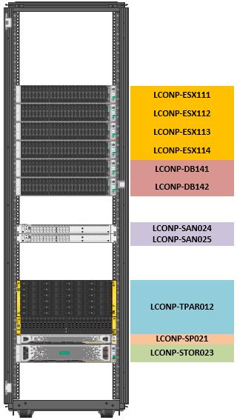

The database servers at the recovery site will be recovered on the following physical servers:

LCONP-DB141.best.lacoe.edu

## Recovered Assets

|  |  |  |  |
| --- | --- | --- | --- |
| **System Category** | **System Name** | **System Type** | **Recovery Priority** |
| Physical Database Server | LCONP-DB141 | Physical Server | RP0 |
| ESXi Physical Hosts | DR1-ESX111, DR1-ESX112, DR1-ESX113, DR1-ESX114, DR1-ESX115 | Physical Server | RP0 |
| Physical Standby Database | bestdr.best.lacoe.edu | Database | RP0 |
| Arista Switches |  | Network Equipment | RP0 |
| Firewall |  | Network Equipment | RP0 |
| ADC (Application Delivery Controller) |  | Network Equipment | RP0 |
| DR Ivanti VPN | dr1-vpn.best.lacoe.edu | Network Equipment | RP0 |
| DR Site LACOE DNS |  | Network Equipment | RP0 |
| Active Directory | LCOMG-AD201, LCOMG-AD202, LCOMG-AD103 (For Production servers) | Virtual Machine | RP0 |
| Jump Box | LCONMG-JMP104 | Virtual Machine | RP0 |
| vCenter | LCOMG-VM201 | Virtual Machine | RP0 |
| Site Recovery Manager | LCOMG-SRM201 | Virtual Machine | RP0 |
| HP ALLETRA StoreServ | COLO1-ALET201 | Storage | RP0 |
| ALLETRA Replicated Datastores | LCOMG-VM201 | Storage | RP0 |
| Database | bestprd | Database | RP1 |
| Vsphere SRM | LCOMG-SRM101 | Virtual Machine | RP2 |
| Jump Box | LCOPMG-JMP104 | Virtual Machine | RP2 |
| LCOPMG-JMP103 | Virtual Machine | RP2 |
| Common Internet File System (CIFS) | LCOPRD-CIFS101W | Virtual Machine | RP2 |
| Web Server | LCOPRD-WEB101L | Virtual Machine | RP2 |
| LCOPRD-WEB102L | Virtual Machine | RP2 |
| LCOPRD-WEB103L | Virtual Machine | RP2 |
| LCOPRD-WEB104L | Virtual Machine | RP2 |
| Remote Desktop Management | LCOMG-RDM101 | Virtual Machine | RP2 |
| Oracle Enterprise Manager | LCOPD-OEM101 | Virtual Machine | RP2 |
| Performance Budgeting | LCOPRD-BUD101L | Virtual Machine | RP3 |
| LCOPRD-BUD102L | Virtual Machine | RP3 |
| Financial | LCOPRD-FIN101L | Virtual Machine | RP3 |
| LCOPRD-FIN102L | Virtual Machine | RP3 |
| HCM | LCOPRD-HCM101L | Virtual Machine | RP3 |
| LCOPRD-HCM102L | Virtual Machine | RP3 |
| LCOPRD-HCM103L | Virtual Machine | RP3 |
| LCOPRD-HCM104L | Virtual Machine | RP3 |
| LCOPRD-HCM105L | Virtual Machine | RP3 |
| LCOPRD-HCM106L | Virtual Machine | RP3 |
| LCOPRD-HCM107L | Virtual Machine | RP3 |
| LCOPRD-HCM108L | Virtual Machine | RP3 |
| Info Advantage | LCOPRD-INFO101W | Virtual Machine | RP3 |
| LCOPRD-INFO102W | Virtual Machine | RP3 |
| ETL | LCOPRD-ETL101W | Virtual Machine | RP3 |
| LCOPRD-ETL102W | Virtual Machine | RP3 |
| Case Management | LCOPRD-CASE101L | Virtual Machine | RP3 |
| LCOPRD-CASE102L | Virtual Machine | RP3 |
| BIRT Forms | LCOPRD-BIRT101W | Virtual Machine | RP3 |
| LCOPRD-BIRT102W | Virtual Machine | RP3 |
| Control-M | LCOPRD-CTRM101L | Virtual Machine | RP4 |
| LCOPRD-CTRM102L | Virtual Machine | RP4 |
|  | LCOPRD-CTRM103L | Virtual Machine | RP4 |
| BigFix Relay | LCOMG-BFR101 | Virtual Machine | RP4 |
| Redhat Satellite | LCOMG-RS102 | Virtual Machine | RP4 |
| Vendor Self Service | LCOPD-VS101 | Virtual Machine | RP4 |
| LCOPD-VS102 | Virtual Machine | RP4 |
| Active Directory | LCOMG-AD101 | Virtual Machine | Out of Scope |
| Temporary VMs for DR | LCOPD-DR101 | Virtual Machine | Out of Scope |
| LCOPD-DR102 | Virtual Machine | Out of Scope |
| Staging VM | LCOSG-WB101 | Virtual Machine | Out of Scope |
| vRealize Operations Manager | LCOMG-OPM101 | Virtual Machine | Out of Scope |
| vCenter | LCOMG-VM101 | Virtual Machine | Out of Scope |
| HPE One View | LCOMG-OVW101 | Virtual Machine | Out of Scope |

## Recovery Strategy Defined

Depending on the type of interruption, the strategy on which this guide is developed can be summarized as follows:

* Disaster recovery for the BEST environment will take place in the recovery site.
* BEST database servers at CoreSite datacenter are operated 7/24/365.
* BEST Non-Prod Oracle cluster is defined at recovery site and will be online and available if a disaster has been called.
* Oracle databases will be failed over to the recovery site using Oracle Data Guard.
* The ESXi cluster and reverse data replication will be confirmed before recovery of the virtual servers and application is performed.
* SRM will initiate a failover of VM guests to the recovery site.
* All VM’s will be powered-on depending on their priority.
* System Admins will validate each VM failed-over and is available.

## Targets for Acceptable Downtime and Data Loss

## RTO and RPO Definitions

* **Recovery time objective (RTO) – i.e. acceptable downtime target:** This is the target for the maximum amount of time to recover IT systems.
* **Recovery point objective (RPO) – i.e. acceptable data loss target:** This is the target for the maximum amount of data loss due to an IT incident (e.g. if it’s necessary to restore data from backups).

## RTA and RPA Definitions

* **Recovery time actual (RTA) – i.e. potential maximum downtime:** This is an estimate of how long it could take to recover IT systems.
* **Recovery point actual (RPA) – i.e. potential maximum data loss:** This is an estimate of how much data loss in hours could result from an IT incident (e.g. if it’s necessary to restore data from backups).

## RTO/RPO and RTA/RPA Summary

These values are based on a full data center failure (i.e. failover to the DR site is required). RTAs/RPAs can be shorter for more-isolated events.

|  |  |  |  |  |
| --- | --- | --- | --- | --- |
|  | Maximum Downtime | | Maximum Data Loss | |
| Criticality | RTO (hh:mm) | RTA (hh:mm) | RPO (hh:mm) | RPA (hh:mm) |
| Tier 1 | 8:00 | **8:00** | *0-:30 | **\*0-00:30** |
| Database | 8:00 | **8:00** | 0:05 | 0:05 |

# Roles and Contacts

|  |  |  |  |
| --- | --- | --- | --- |
| **Name** | **Role** | **Phone Number** | **Email** |
| Robert Bayles | DR Lead | (562) 922-6098 | Bayles_Robert@lacoe.edu |
| Robert Dotson | DR Lead |  | Dotson_Robert@lacoe.edu |
| Ruben Ybarra | Management Team | (562) 774-7923 | Ybarra_Ruben@lacoe.edu |
| Joshua Lee | Management Team |  | Lee_Joshua@lacoe.edu |
| Felix Ortiz | Management Team |  | Ortix_Felix@lacoe.edu |
| Jeff Rhey | Recovery Team (SVR) | (562) 774-8493 | Rhey_Jeff@lacoe.edu |
| John Reed | Recovery Team (SVR) | (562) 774-7923 | Reed_John@lacoe.edu |
| Mario Dongo | Recovery Team (SVR) | (562) 445-5899 | Dongo_Mario@lacoe.edu |
| Paul Kaila | Recovery Team (SVR) | (909) 257-4449 | Kaila_Paul@lacoe.edu |
| Benjamin Kaila | Recovery Team (DB) | (818) 279-1781 | Kaila_Benjamin@lacoe.edu |
| Wendy Yang | Recovery Team (DB) |  | Yang_Wendy@lacoe.edu |
| Ravi Gupta (CGI) | Database Admin | (929) 459-9292 | ravinder.gupta@cgi.com |
| Bryan Chan | Recovery Team (NS) | (562) 922-6648 | chan_bryan@lacoe.edu |
| Michael Conception | Recovery Team (NS) | (408) 685-7247 |  |
| Tom Cheung | Recovery Team (NS) |  |  |
| Abir Chakraborty | Application Manager | (562) 401-5376 | Chakraborty_Abir@lacoe.edu |
| Prashanth Koppu | Application Admin | (562) 999-6767 | Koppu_Prashanth@lacoe.edu |
| David Jan | Application Admin | (562) 533-1677 | jan_david@lacoe.edu |
| Boon Chen | Application Admin | (626 465-8991 | Chen_Bounhong@lacoe.edu |
| Claire Nguyen (CGI) | Application Admin | (909) 634-0462 | claire.nguyen@cgi.com |
| Tim Carter | Nightly Operations | (951) 440-9100 | Carter_Timothy@lacoe.edu |
| Jerry Zaharias | Nightly Operations | (951) 236-4929 | Zaharias_Jerry@lacoe.edu |
| Maria Navarro | Nightly Operations | (818) 648-5702 | Navarro_Maria@lacoe.edu |
| Sangeeta Gupta | CM/HCM Admin | (562) 922-6258 | Gupta_Sangeeta@lacoe.edu |
| Yumeka Seabrooks | HCM Admin | (951) 315-8727 | Seabrooks_Yumeka@lacoe.edu |
| Hong Lei | infoAdv Admin | (626) 823-1460 | Lei_Hong@lacoe.edu |
| Jenny Zermemo | FIN/PB Admin |  |  |
| Lisa-Ann Hinkson | FIN Admin | (562) 922-8794 | Hinkson_Lisa-Ann@lacoe.edu |
|  |  |  |  |
|  | PB Admin |  |  |
|  | FIN Admin |  |  |
|  | HCM Admin |  |  |
|  | infoAdv Admin |  |  |

Note: For more information on these tasks including runbooks, assignees, and estimated time, refer to the DR spreadsheet

# Appendices





